|  |
| --- |
| 新东方在线英语学习 |
| 新概念 1 册 |
| Lesson63-64 |



扫一扫。更多有趣的英语资讯。

# Lesson 63 单词讲解

1. better: adj.形容词 well 的比较级

good-better well-better

I’m well.— I’m better.

1. certainly: adv.当然
   * Can you help me?
   * Certainly!
2. get up: 起床

go to bed\ go to sleep

三单形式：

gets up\ goes to bed\ goes to sleep 4.yet: adv. 还，仍

否定、疑问句末

你还不能去上班呢。You can’t go to work yet. 他还不会开车呢。

He can't drive yet. 5.rich: adj.油腻的

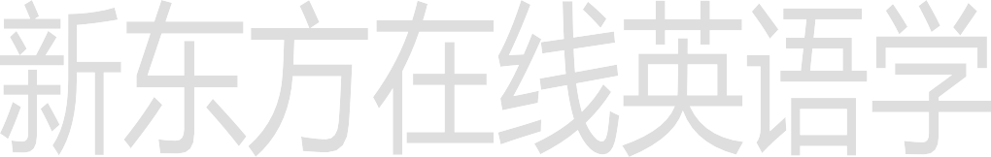rich food

1. 富有的

a rich man

1. 华丽的

rich silk si ao ke

1. 肥沃的

rich land 6.food: n.食物

rich food, 油腻的食物mild food, 清淡的食物spicy food,辛辣的食物green food, 绿色食品fast food, 快餐

sea food, 海鲜

7.remain: v.保持，继续

# Lesson 59 课文讲解

1. You look very well.

感官动词- adj.

你看起来很开心啊。You look very happy. 他看起来很忙啊。He looks very busy.

1. 你现在好多了，但你还不能去上学呢。

You are better now，

but you mustn’t go to school yet. yet, 否定疑问句末

mustn’t, 绝对不可以

1. 你必须再卧床两天。

卧床, stay in bed 再, again You must stay in bed two days again.

* 1. again, 再一次地

Try again. Say it again. another two days another two weeks

* 1. **for +** two days

翻译为汉语不需要，介词+时间

for+ 时间段，长达

for a week\ for two months\ for three years at+ 点

at 2:00 at 4:00 on+ 天

on Sunday on Jan. 7th in+ 月、季、年

in April. in summer in 2014

你必须再卧床两天。

You must stay in bed for another two days.

我必须在北京再呆两周。

I must stay in BJ for another two weeks.

我们必须再学两年英语。

We must study English for another two years.

1. have a temperature have a fever

三单：has

He has a fever.

Do you have a fever? Does he have a fever? I don’t have a fever.

He doesn’t have a fever.

1. 卧床:

stay in bed remain in bed

1. 他每天可以起床大约 2 小时。

He every day can get up about two hours.

谁？- 干什么？

for+ 时间段，长达

He can get up for about two hours every day . every day & each day

every 整体

each 个体

Hi, every one! 大家好！ Each man has his own name 每个人都有自己的名字。

1. You must keep the room warm. I’m going to paint it pink.

must

1. 疑问：

我必须清扫屋子吗？

Must I clean the room？

1. 否定：

我不必清扫屋子。

I mustn’t clean the room.

# Lesson 63 语法讲解



mustn’t: 绝对不可以，禁止你绝对不可以在这大吵。You mustn’t make noise here.

你绝对不可以在这吸烟。

You mustn’t smoke here.

我不必清扫屋子。

I mustn’t clean the room.

I don’t need to clean the room. don’t need to… 不必，不需要

1. play: v. 玩
   1. play games 玩游戏

# Lesson 64 单词句型讲解

* 1. play the violin 弹奏，拉琴
  2. play football\ basketball 打球、踢球

1. match: n.火柴mai chi
2. matches
3. talk: v.谈话

talk to sb. 与…谈话

Don't talk to me like that! Don’t talk to strangers

si zhui en zher s

1. library: n.图书馆in the library
2. drive: v. 开车

drive a car 6.so: adv.如此地

so beautiful \ so much 7.quickly: adv.快地

He drives so quickly.

1. lean out of : 身体探出

lean [liːn], 倾斜，偏向，弯斜

lean out of the window 把身子探出窗户

1. break: v.打破10.noise: n. 喧闹声nao ai zi

发出噪音

make the noise

# Lesson 63&64 知识拓展

break

1. give me a break

Give me a break! I am nervous enough as it is?

行行好吧,我已经够紧张的了。

Give me a break! Is she blind or what?



拜托，她眼睛瞎了吗?

拜托/ 放过我吧/ 行行好吧/ 不要强求我

2. break up

They decided to break up the partnership.

他们决定终止合作关系。

She breaks up with her boy-friend.

她和男朋友分手了。终止/ 结束/ 分手